Virag Szabo

virag.szabo@student.nhlstenden.com

Version 1.1

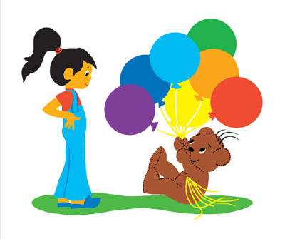

BoriboN Game

Proposal Document

Contents

Introduction 2

Description 2

Technical Requirements 3

Operating system 3

Language 3

Hardware 3

Windows specifications 3

Software 3

Timeline 4

# Introduction

I am going to provide a software solution for my mother who is planning to make a summer camp for Hungarian little kids whose parents want them learning their other native language. My mother, Anita Foldi is working at an online Hungarian school which is based in the USA however, they are providing lectures worldwide, and she also has her own business for teaching kids the beauty of our native tongue. The approach I am going to follow is that the game I am going to develop can make a fun time while the children are learning. For this final assignment of JavaScript, the language of the website is going to be Dutch since I am studying IT in English in the Netherlands.

# Description

The idea of this Boribon Game is that the user can see seven balloons which belongs to the little bear, Boribon. Boribon is going to ask for help fixing the gifts which the player needs to paint. When the user clicks on a balloon, she/he can hear the name of the color. After, the child paint all the presents of Boribon (clicked all the objects), the game is ended. Boribon can go to give the presents away. Also, the children will memorize those colors and able to tell them apart from each other.

# Technical Requirements

## Operating system

All operation systems that can run JavaScript (at best the latest version, ECMAS2021; at least ECMAS2016).

## Language

JavaScript and jQuery

## Hardware

|  |  |
| --- | --- |
| Type | Lenovo |
| Device name | DESKTOP-DG18NQA |
| Processor | Intel® Core™ i7-3537U CPU @ 2.00GHz 2,50 GHz |
| Installed RAM | 8.00 GB (7.88 GB usable) |
| Device ID | 79674A67-415B-44AA-8594-8BA5460C01A2 |
| Product ID | 00326-10000-00000-AA441 |
| System type | 64-bit OS, x64-based processor |
| Pen and touch | Touch support with 10 touch points |

### Windows specifications

|  |  |
| --- | --- |
| Edition | Windows 10 Home |
| Version | 20H2 |
| Installed on | 25/04/2021 |
| OS build | 19042.985 |
| Experience | Windows Feature Experience Pack 120.2212.2020.0 |

## Software

Visual Studio Code. Using the latest version, thanks to auto-updates.

# Timeline

The project is going to take approximately 4 weeks, from the date of confirmation.

**The timeline and process steps are listed below:**

|  |  |
| --- | --- |
| Weeks | Tasks |
| 3 | Getting an idea, make the proposal document and the technical design. |
| 4-7 | Implement and test the code continuously. |
| 8 | Hand-in the final assignment. |